Lab Assignment 4 - Basic SELECT Queries

## Instructions

1. Answer the below question in the boxes.
2. Please submit the assignment through TalentLabs Learning System.

## Open the Movies database

Open the movies database(movies.db) using DB Browser for SQLite. You should see 5 tables in the database.

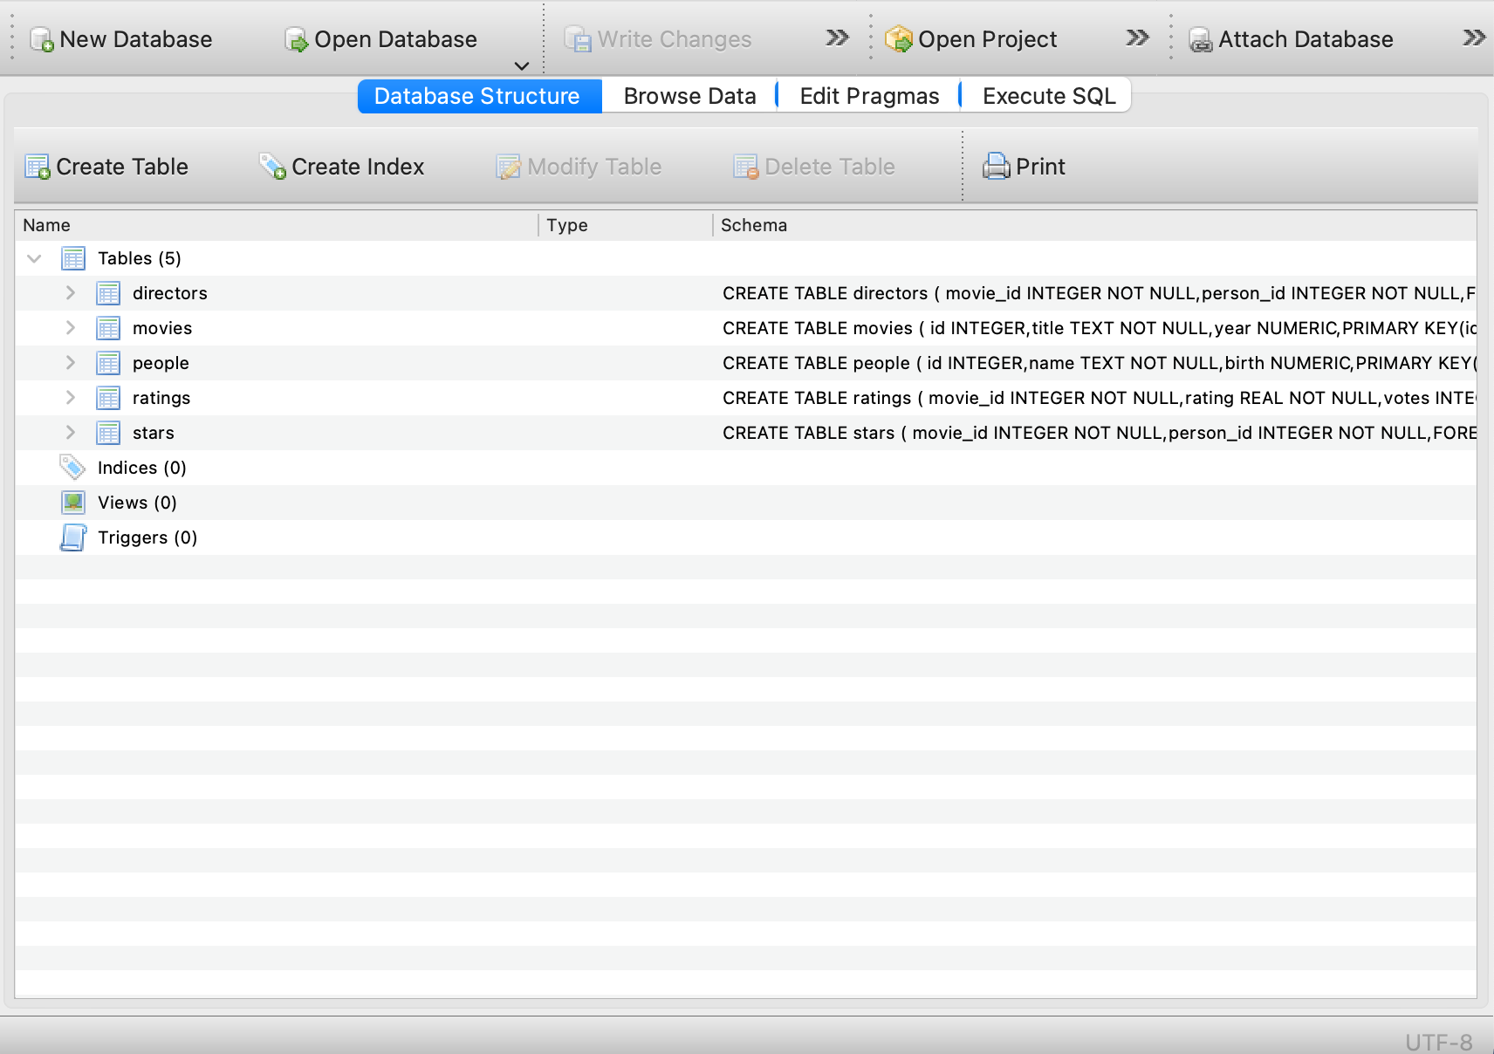

## 

## 

## Query Exercises

For the exercises below, please write the required query and **test in DB Browser for SQLite**. When you succeed, please copy and paste the query you used in the answer box. You can reference the “Expected Output” for what is expected to come out from your query execution.

1. Write a SQL query to list the titles of any 5 movies.

**Expected Output:** a table with a single column for the title of 5 movies.

|  |
| --- |
| SELECT title  FROM movies  LIMIT 5 |

1. Write a SQL query to list the movie titles sorted alphabetically.

**Expected Output:** a table with a single column containing a sorted movie title list. You can only capture the first 10 rows for illustration.

|  |  |  |  |  |  |  |  |  |  |  |
| --- | --- | --- | --- | --- | --- | --- | --- | --- | --- | --- |
| SELECT title  FROM movies  ORDER BY title ASC  LIMIT 10   |  | | --- | | !Women Art Revolution | | #1 Serial Killer | | #19 | | #1915House | | #5 | | #5 | | #50Fathers | | #66 | | #73, Shaanthi Nivaasa | | #82 Summits | |

1. Write a SQL query to list the movie titles sorted alphabetically and reverse chronologically.

**Expected Output:** a table with a single column containing a sorted movie title list. You can only capture the first 10 rows for illustration.

|  |  |  |  |  |  |  |  |  |  |  |
| --- | --- | --- | --- | --- | --- | --- | --- | --- | --- | --- |
| SELECT title  FROM movies  ORDER BY title ASC, year DESC  LIMIT 10   |  | | --- | | !Women Art Revolution | | #1 Serial Killer | | #19 | | #1915House | | #5 | | #5 | | #50Fathers | | #66 | | #73, Shaanthi Nivaasa | | #82 Summits | |

1. Write a SQL query to list all the unique people name in alphabetical order

**Expected Output:** a table with a single column containing a sorted unique name list. You can only capture the first 10 rows for illustration.

|  |  |  |  |  |  |  |  |  |  |  |
| --- | --- | --- | --- | --- | --- | --- | --- | --- | --- | --- |
| SELECT DISTINCT name  FROM people  ORDER BY name ASC  LIMIT 10   |  | | --- | | !'aru Ikhuisi Piet Berendse | | !Nqate Xqamxebe | | $hutter | | 'A.J.' Marriot | | 'Aha Punana Leo | | 'Atlas' Ramachandran | | 'Atolomake Helu | | 'Bad' Chad Broussard | | 'Beatle' Bob Matonis | | 'Big' James Wroblewski | |

**- End of Assignment -**